Continuous Integration and Continuous Deployment Lab

Experiment – 4

**Name – Harivansh Mathur**

**Roll No – R171218043**

**Static Code Analysis using SonarQube**

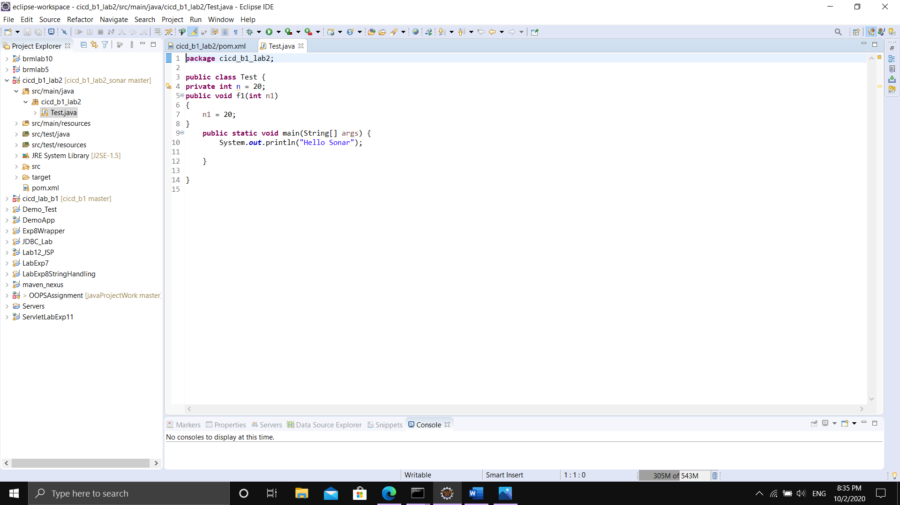

Making a Maven Project with a simple Java Program to test

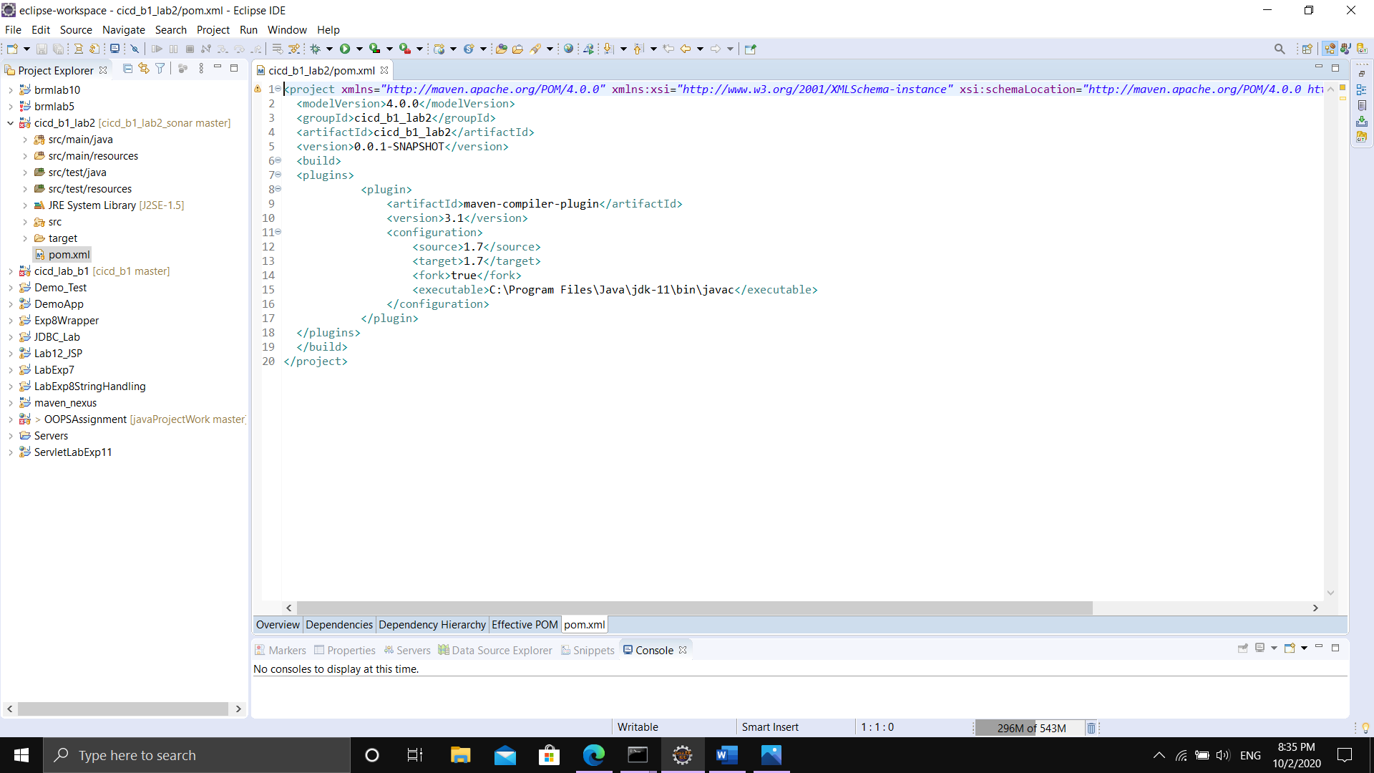

POM.xml file for that maven project

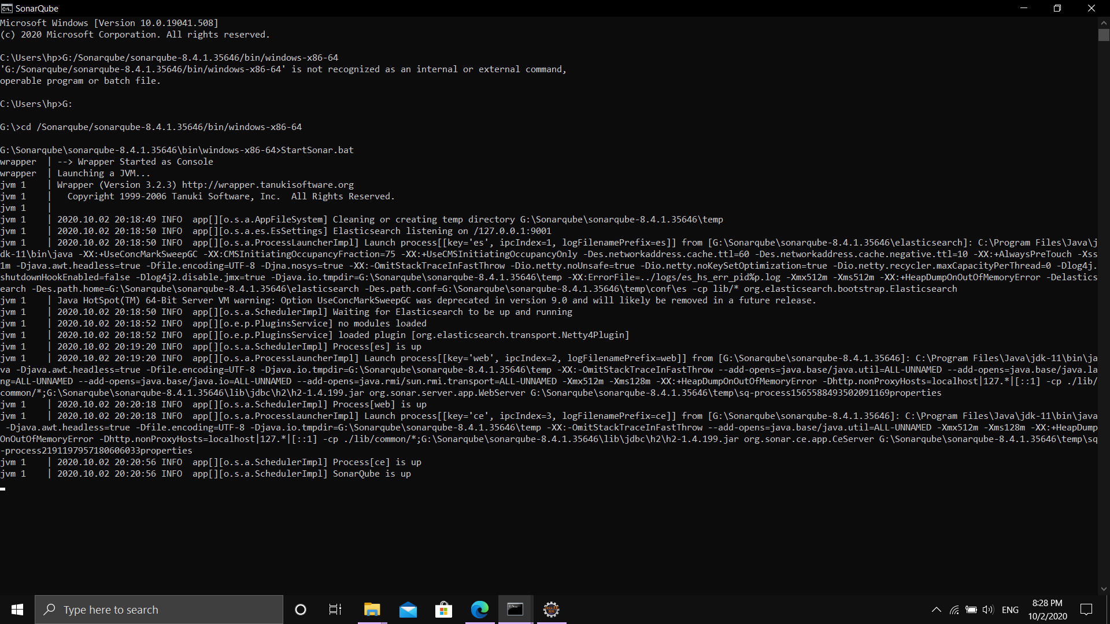

Starting SonarQube from command line

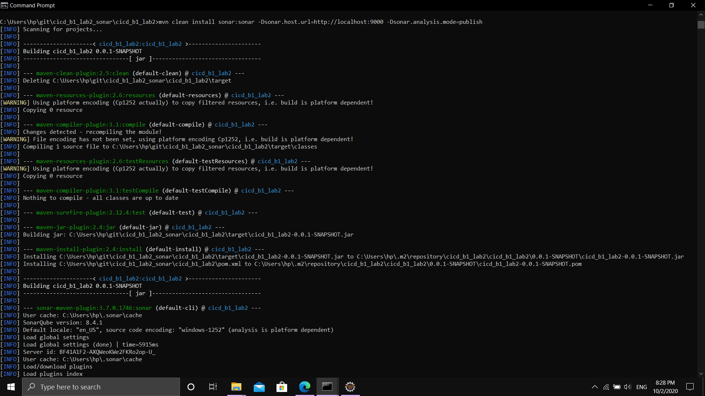

In other cmd window go the directory where that project is located and run the following – “ mvn clean install sonar:sonar -Dsonar.host.url=http://localhost:9000 -Dsonar.analysis.mode=publish”

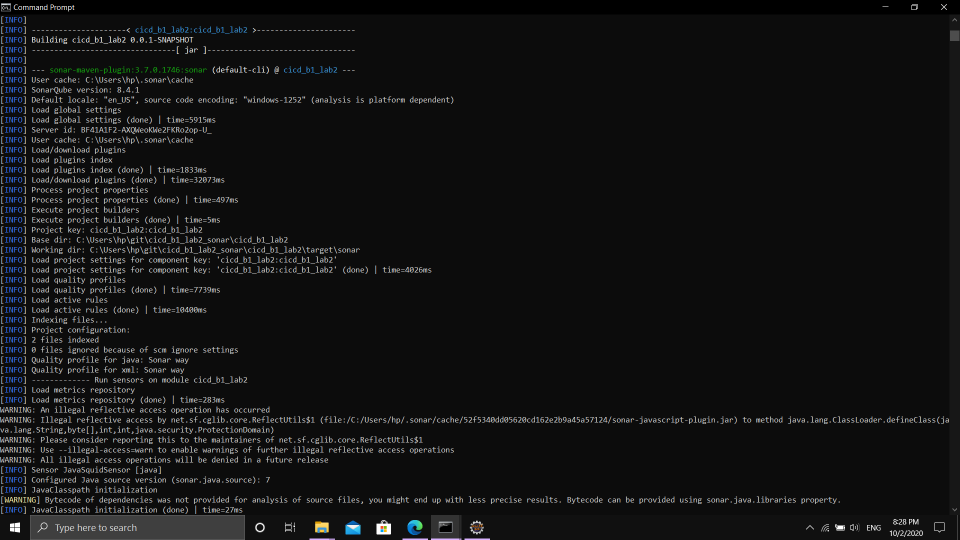

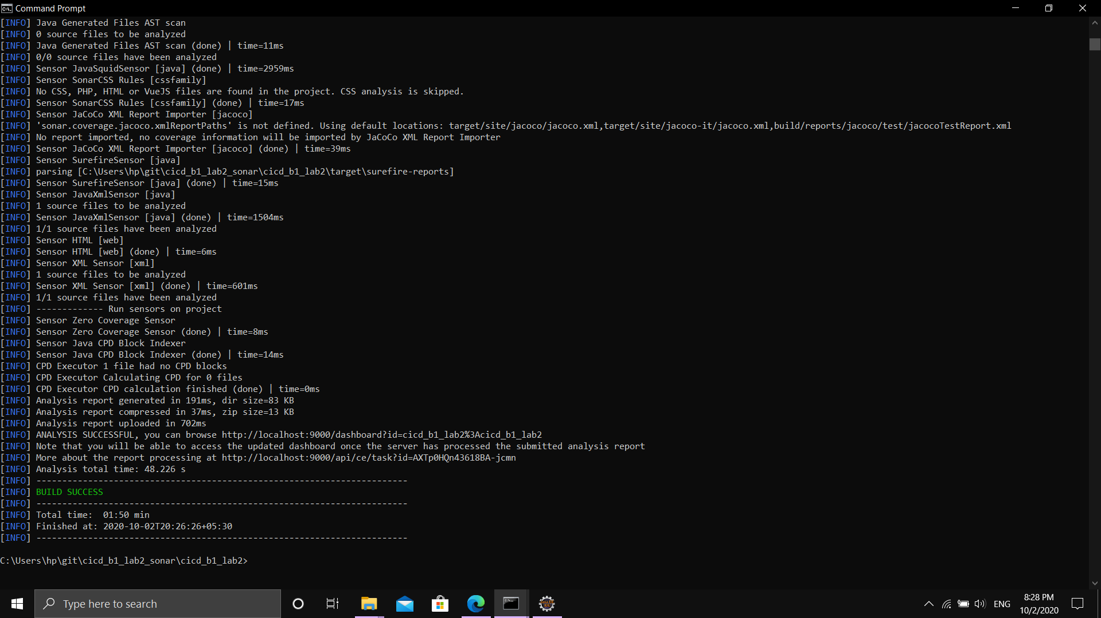

Output of that command Build Success and the code analysis is printed here